Miracle League of Northwest Montana
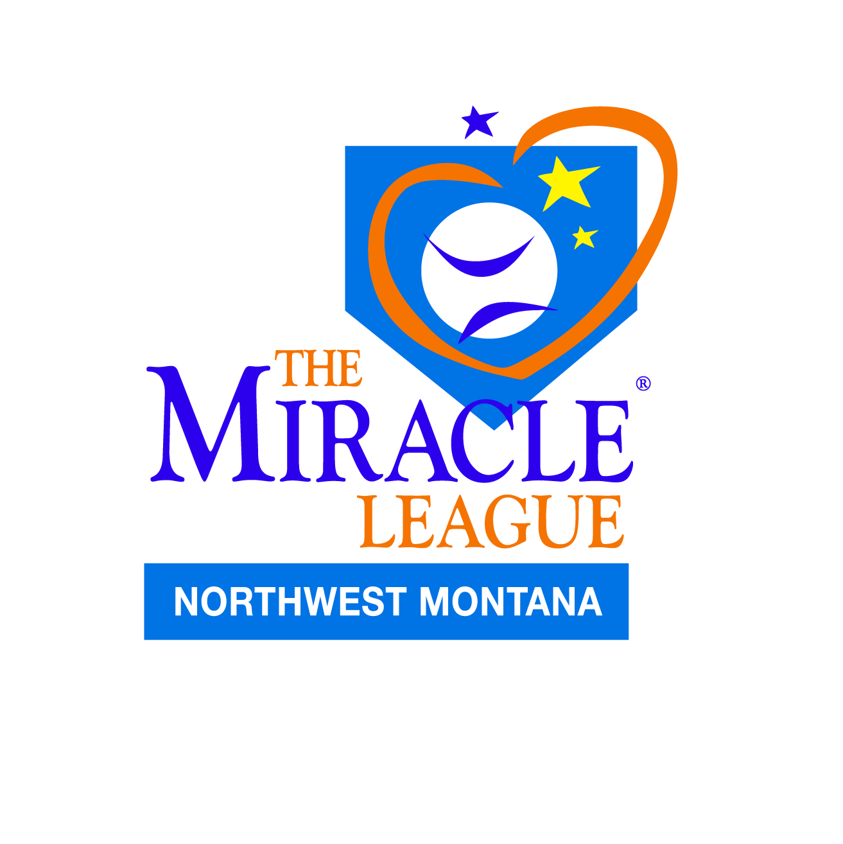

2025 Booster and Sponsorship Donation Form

We are an all-volunteer run program to provide a free, summer baseball program, on a fully accessible field, for children and adults with a special need or disability of any kind or severity. All donations are tax deductible through the 501(c)3 non-profit organization designation.
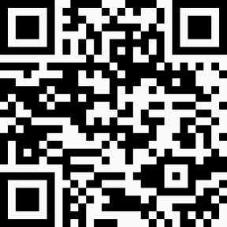
Annual Sponsorship and Booster Donations:
https://givebutter.com/2025MiracleNWMT

We have also begun a Capital Campaign to resurface our fields, enlarge dugouts to have ample room for wheelchairs, add shade features and improve storage.
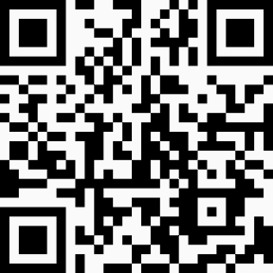
Field Resurfacing and Dugout Improvement Capital Campaign:
https://givebutter.com/NWMTMLFieldReplacement

____ $1,000 League Sponsorship. $500 Team Sponsorship Team:___________
Premier Entrance Season Banner Placement* Season Dugout Banner Placement*
Name/Logo on Schedules, Website, Facebook Name listed on Schedules, Website, Facebook,
and announced at Opening Ceremonies and Awards. and announced at Opening Ceremonies and Awards.
____ $250+ Opening Ceremonies Sponsor ____ $100 Game Night Hot Dog Social Sponsor
Provides Dinner for Families and Players Provides for free Hot Dog, Chip and Drink on a Game Night
Season Outfield Banner Placement* Weekly Entrance Banner Placement*
Name announced at Opening Ceremonies Signage and Announcements at Concessions

____ $300 Awards Sponsor ____ $______ Miracle League Booster
Provides for Year End Medal and Certificates To be used where needed with any excess to field fund
Season Outfield Banner Placement* Donations over $100 will receive a ML Booster logo gift
Name listed on Certificates.

Please use the links above or return this form with check payable to The Miracle League of Northwest Montana. 100% of all donations will be spent directly for the needs of the program.
(*Banners, if applicable and desired, are to be provided by sponsor and placed by Miracle League)

Donor’s Name Email Phone Number

Street Address City State Zip Code

Donor’s Signature:__________________________________ Date:____________________

Mail donations to: Miracle League c/o Jen Johnson 259 Northland Drive Kalispell, MT 59901

